Low Complexity Fractal-Based Image Compression Technique
Sunil Kumar and R. C. Jain
IEEE Transactions on Consumer Electronics, Vol. 43, No. 4, pp. 987-993, Nov. 1997
Abstract
A fast image compression technique as well as its Progressive Image Transmission (PIT) version using fractals is presented which uses a small pool of domains extracted using visually significant patterns..
- Introduction
Lately fractal based techniques are gaining popularity on account of very high predicted compression ratios and their suitability for broadcast type applications due to very simple decoder. A low complexity fractal technique using subjective criterion, based on human visual system (HVS), is discussed in this paper, which is also suitable for progress image transmission.
In this technique, 4x4 range blocks are classified into perceptually significant shade and edge blocks.
- Coding Scheme
An image can be adequately represented by low-frequency blocks (shade) and blocks containing visual patterns (edges).

- Block Classification
The input image is first partitioned into 4x4 non-overlapping range blocks and 8x8 overlapping domain blocks. If the maximum D_{r} of a block is greater than the Weber’s threshold (Te), the block is assigned to the corresponding edge class, otherwise it is treated as a shade block.
- Encoding of Shade Blocks
Id Code | Error Mean | Reconstructed value
00 | ⏐Error mean⏐ ≤ 2 | 0
01 | 2 < Error mean⏐ ≤ 6 | 4
10 | -6 < Error mean < -2 | -4
11 | ⏐Error mean⏐ > 6 | 4-bit quantiser

- Encoding of Edge Blocks
Initial, 52 domain pools are chosen, one for each edge pattern, and each domain block of the image is assigned to one of them corresponding to its edge pattern. All the 52 edge patterns can be visualize by 13 patterns with the help of 4 isometries for each given edge pattern.

- Decoding Procedure
At the receiver, the x & y position of the domain block, corresponding to a particular range block, is obtained from the overhead information using its 4-bit address.

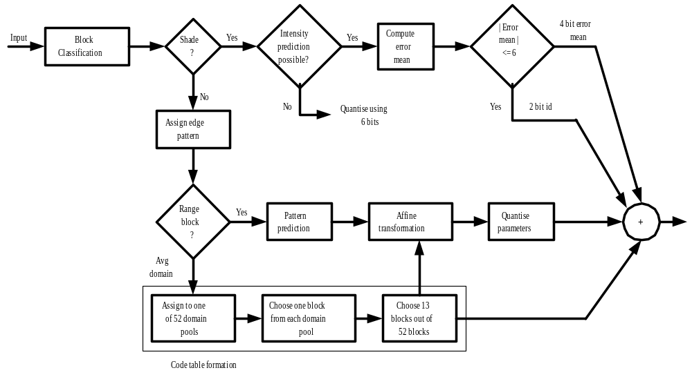
Fig :Block diagram of the proposed coding scheme.

- Simulation Results
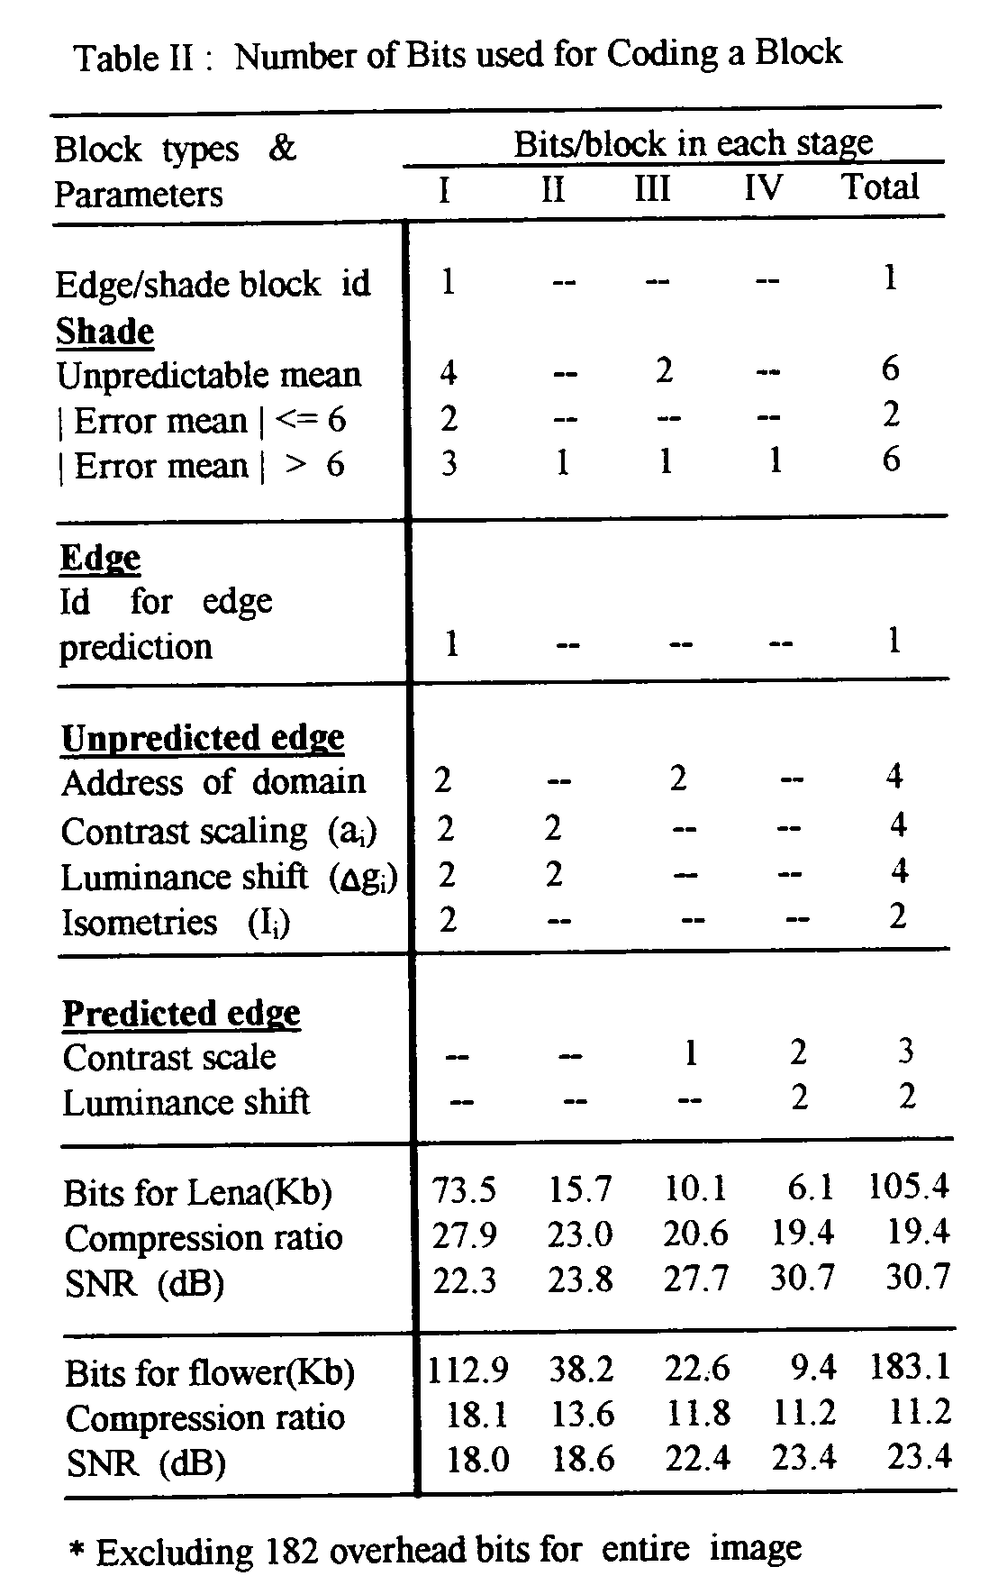
- Conclusions
The main features of the proposed technique are: (compare to Jacquin)
- Higher compression ratio
- Only O(n_{r} + n_{d}) searches are required.

Created by : Chia-Hao Yang
Date : Apr 8, 1998

